# **Buy Verified PayPal Accounts**

#### **Buy USA Verified PayPal account**

Are you looking to buy USA verified PayPal accounts? You are in the right tract. We provide genuine and, USA and UK verified PayPal business and personal accounts. USA and UK verified account ensures the trust PayPal for secure and reliable online transactions.

##### **Our Accounts Info & Offers:-**

* Email verified
* Phone number verified
* Address verified
* SSN and Passport verified
* Drivers’ License verified
* Bank statement verified
* Billing papers verified
* LLC verified (for business accounts)

#### **If you have more questions then contact us we will help you solve your all questions answer.**

##### **Contact US**

##### **Email: usasmmzillow@gmail.com**

##### **Skype:** [**Usasmmzillow**](https://join.skype.com/invite/stfkfcTNfbyw)

##### **Telegram:** [**@usasmmzillow**](https://t.me/usasmmzillow/)

##### **What’s App:** [**+19029125959**](https://wa.me/+19029125959)

##### **Buy Verified PayPal Accounts**

## PayPal make easier the global transactions worldwide, providing a convenient platform for online purchases and money transfers. A PayPal account offers secure and swift online payments. The benefits include ease of use, widespread acceptance, and buyer protection. With its higher security measures, users can confidently link their bank accounts, credit, or debit cards to send and receive funds. PayPal’s widespread acceptance among merchants enables customers to shop from a vast array of online stores. To [**buy verified PayPal accounts**](https://usasmmzillow.com/product/buy-verified-paypal-accounts/), place order.

PayPal has swiftly shifted from a simple auction payment platform to a global financial management system. PayPal ensures buyer protection and safeguards consumers against fraud. The service streamlines the payment process, allowing quick checkout, making it a preferred choice for both personal and business transactions and trading. It also offers easier payment options, including the ability to pay in installments, and the PayPal credit feature, which allows for deferred payments.

### **Basic advantages of using PayPal accounts-**

* PayPal shields users with top-notch security protocols. Two-factor authentication and data encryption secure accounts. Transactions are monitored round-the-clock against fraud. So, we suggest you to buy verified PayPal accounts at usasmmzillow
* Using PayPal means swift and simple online payments. Users enjoy seamless checkout experiences. Send and receive money effortlessly across diverse platforms.
* International users benefit from PayPal’s currency flexibility. Easily handle transactions in various global currencies. Enjoy competitive exchange rates directly through your account.
* PayPal provides flexible solutions tailored to business size and type. Customization options cater to unique demands. This personalization ensures that businesses of all scales get precise payment features.
* PayPal’s Effortless connections with e-commerce platforms exist. This sets up a smooth transaction flow. Payment processing becomes swift and reliable.

### **How PayPal facilitate businesses?**

PayPal accounts facilitate secure money transfers for businesses globally. They streamline online transactions and trading with ease and efficiency. The service caters to a diverse range of transaction needs, from small-scale P2P transfers to large-scale business operations requiring invoicing and mass payments. PayPal offers a trusted payment gateway that integrates seamlessly with e-commerce sites. Buy verified PayPal accounts for your personal or business use purpose, usasmmzillow is the right place.

### **What is the role of PayPal accounts in e-commerce?**

PayPal accounts play an important role in e-commerce, offering streamlined transactions for individuals and businesses. PayPal accounts greatly simplify the way businesses handle transactions. With a single platform, companies can receive and send payments globally. This ease of use helps businesses to save time and reduce errors. Customers also enjoy the convenience and speed of PayPal transactions. Buy PayPal accounts and set up PayPal for your e-commerce business.

### **Why People Should Buy USA Verified PayPal Account?**

If you [**buy verified PayPal accounts**](https://usasmmzillow.com/product/buy-verified-paypal-accounts/) then it offers security and enhanced access to a wide range of services. Consumers and businesses trust PayPal for secure and reliable online transactions. A USA verified PayPal account signals credibility and adherence to stringent payment processing standards. It opens doors to services and features exclusive to verified users, like higher transaction limits. Buy old PayPal accounts at usasmmzillow to get higher limits.

#### **How PayPal being the especial part of international trading management?**

When you are engaged in international trade, PayPal is a game-changer and best assistant to you. It supports multiple currencies, allowing easier currency conversion. Businesses can thus expand their market reach without worrying about complex currency issues. These features position PayPal as a vital tool for global business operations. Its services enable swift payment processing on various online platforms.

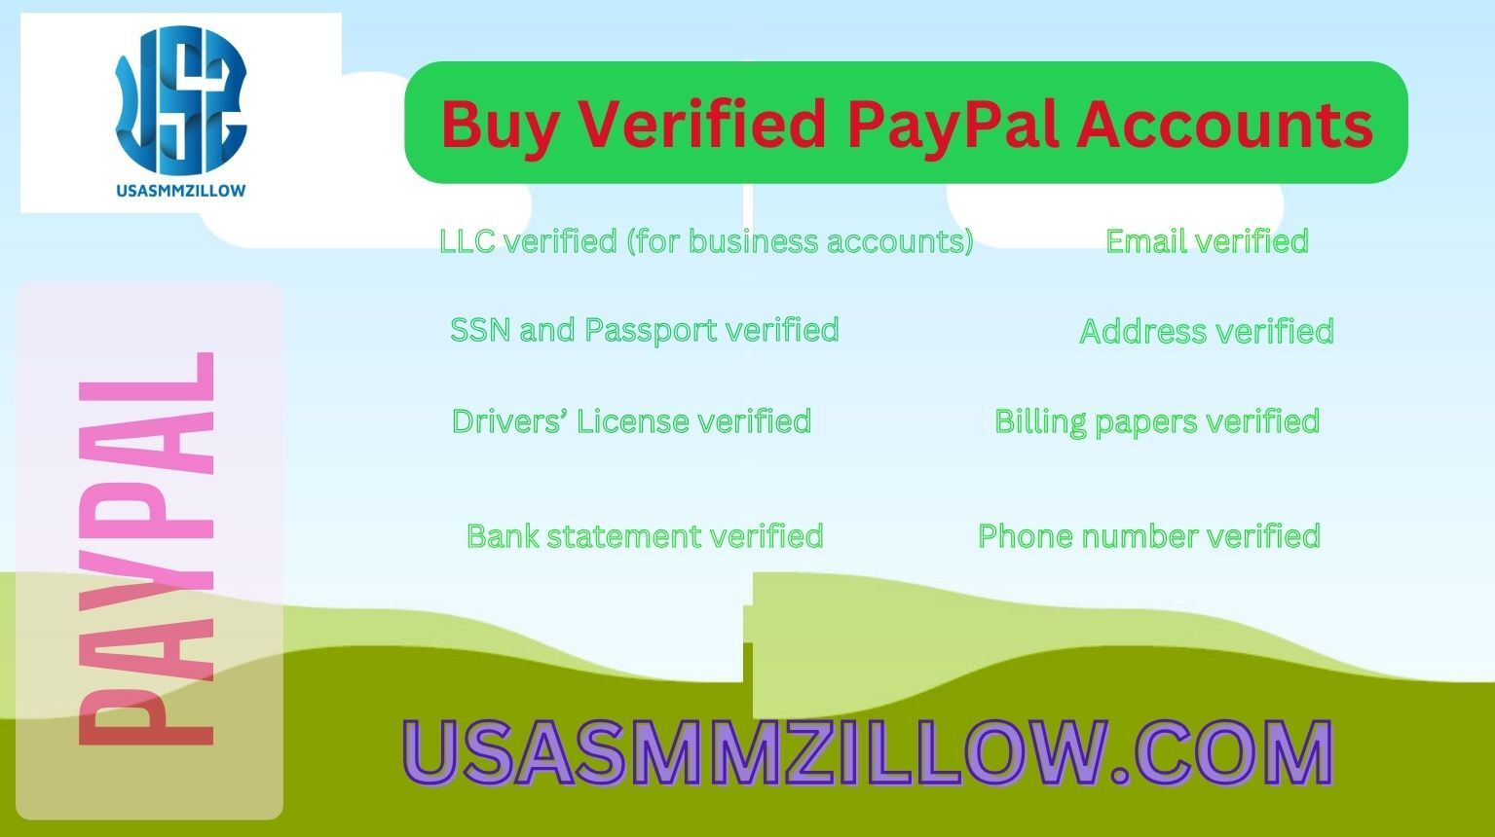Buy Verified PayPal Accounts

#### **Why Individuals like to buy PayPal accounts?**

Individuals across the globe can now transact money with just a few clicks. For individuals, PayPal simplifies online shopping by acting as a middleman that protects sensitive financial information. PayPal simplifies money transfers for everyone. People around the world send and receive money with ease. It’s faster than going to a bank. Parents can quickly send pocket money to their children.

PayPal accounts help people manage money safely. Friends and families send cash with ease. Entrepreneurs use PayPal to get paid for their services. Friends can split bills after a meal. Here you need your legal address and a phone no. PayPal has drastically changed the way people handle online transactions. This platform has enabled easy, quick, and secure payments for both personal use. [**Buy PayPal accounts.**](https://t.me/usasmmzillow/)

#### **Why PayPal suggest it users to verify account?**

Verification of personal and business accounts adds a layer of security, enhancing trust among users while keeping fraud at bay. As you embark on this simple process, the documentation you provide ensures your account’s authenticity, safeguarding your online monetary dealings. A verified status not only secures your finances but also unlocks the full spectrum of PayPal features. To avoid the verification process buy old PayPal accounts at usasmmzillow.

Account verification making the effort a smart investment in seamless online operations. Verifying a PayPal account is crucial for both business and personal users. It boosts limits and increases trust. Personal accounts are for shopping or sending money to friends. Business accounts come with more features for selling services or goods. Each type needs different documents for verification.

#### **What are the documents needed to verify a personal PayPal account?**

To verify a PayPal Business Account, you need proof of identity, address, and bank account details. Personal Accounts require identification such as SSN, Passport, and proof of address. To get higher transaction limit, buy old PayPal accounts at [**usasmmzillow**](https://usasmmzillow.com/)at cheap price.

To verify a Personal PayPal Account, you need specific documents. A proof of your Identity such as your passport or driver’s license is necessary. Also, you must provide proof of your address. It will be a utility billing papers and bank statement.

Your account becomes more secure after verification. The process is not hard. Upload the documents through PayPal’s platform. Make sure your details are clear and current. PayPal will then review them.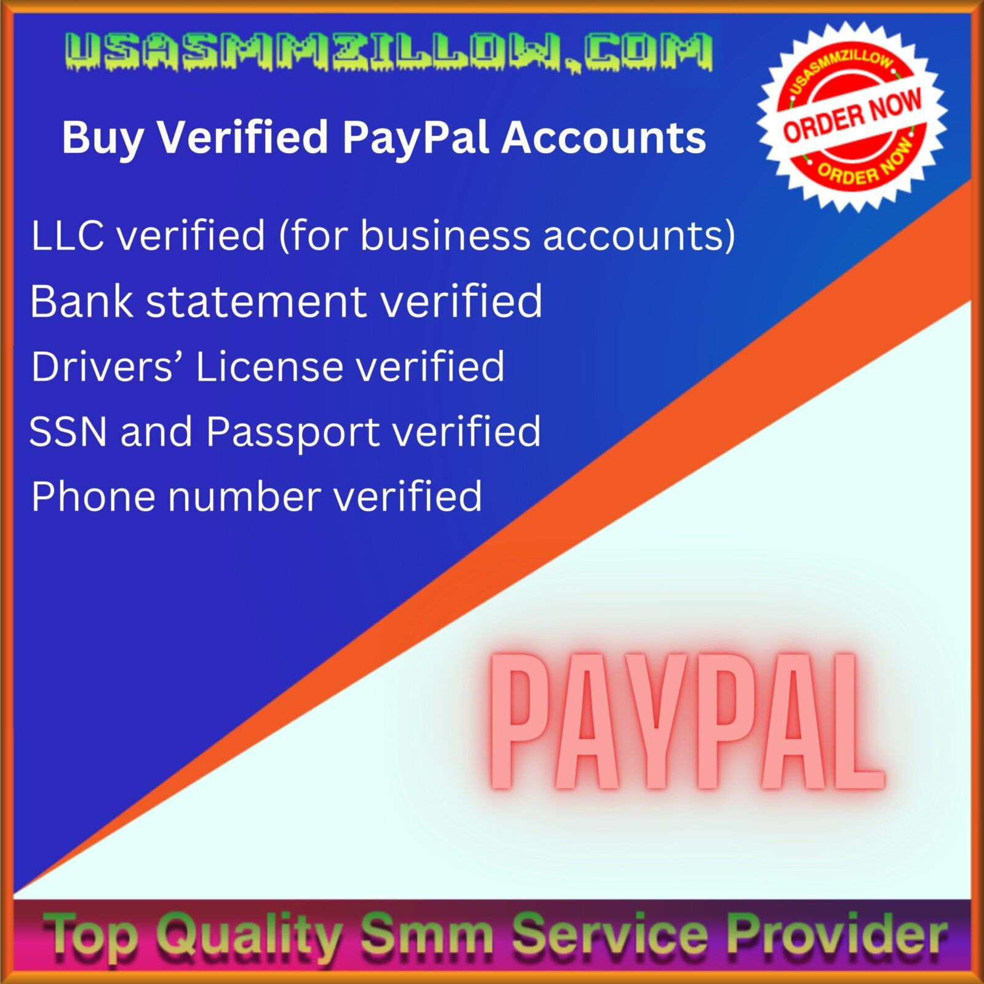

#### **How to verify a PayPal business account and why verification is important?**

* To verify a Business PayPal account, you need specific documents. Businesses must provide their proof of identity. This comes in the form of a government-issued ID.
* A company needs to show legal business information. This includes the business name and address. Documents like a bank statement or utility bill are used. Buy PayPal accounts for your e-money safety.
* For the business’s operational details, submit a proof of business operations. It includes tax documents or a business license. Additional proof may include sales invoices or a commercial lease agreement.Verifying a PayPal account means adding more security to your money. This process uses specific documents to protect your account. This ensures your business’s operations are valid and current.