# **Buy Verified Airbnb Accounts**

##### **Buy Verified Airbnb Accounts**

###### **. It is ready to be used.**

###### **. Full Documents Validated**

###### **. Utilized a legitimate IP**

###### **. All verifications completed**

##### **If you have more questions then contact us we will help you solve your all questions answer.**

##### **Contact US**

##### **Email: usasmmzillow@gmail.com**

##### **Skype:** [**Usasmmzillow**](https://join.skype.com/invite/stfkfcTNfbyw)

##### **Telegram:** [**@usasmmzillow**](https://t.me/usasmmzillow/)

##### **What’s App:** [**+16162075976**](https://wa.me/+16162075976)

# **Buy Verified Airbnb Accounts**

Looking to [**buy verified Airbnb accounts**](https://usasmmzillow.com/product/buy-verified-airbnb-accounts/) Check out reliable providers for a hassle-free experience.

Purchasing verified Airbnb accounts can save you time and effort in creating and verifying accounts yourself. By choosing a trusted seller, you can access ready-to-use accounts that meet Airbnb’s verification standards. With a verified account, you can start listing your property or booking accommodations without any delays.

Ensure to research and select a reputable provider to avoid any potential issues in the future. Let’s explore the benefits of buying verified Airbnb accounts and how it can streamline your Airbnb hosting or booking process.

## **The Evolution Of Travel**

Travel has evolved significantly over the years, with the emergence of innovative platforms such as Airbnb revolutionizing the way people experience accommodations. Traditional hotel stays have given way to a more personalized and immersive travel experience, allowing travelers to connect with local cultures and communities in a way that was previously unimaginable.

### **Airbnb’s Impact On Tourism**

Airbnb’s impact on tourism has been profound. By providing a platform for individuals to rent out their homes or spare rooms, Airbnb has not only expanded the options available to travelers but has also contributed to the economic growth of local communities. This has led to a more diverse and authentic travel experience, as visitors are no longer confined to standard hotel accommodations but can instead choose from a wide range of unique and culturally immersive lodging options.

### **Why Choose Airbnb?**

Airbnb has revolutionized the way people travel, offering a wide range of unique accommodations and experiences that go beyond traditional stays. If you are looking for a memorable and authentic travel experience, Airbnb is the perfect choice. Here are a few reasons why you should consider choosing Airbnb for your next trip.

### **Airbnb Account Verification**

Welcome to our blog post about [**buy verified Airbnb accounts**](https://usasmmzillow.com/product/buy-verified-airbnb-accounts/) In this article, we will discuss the importance and benefits of having a verified Airbnb account. Whether you are a host or a guest, having a verified account can give you peace of mind and enhance your overall experience on the platform. So, let’s dive in and explore the Airbnb verification process and the advantages it offers.

### **Airbnb Verification Process**

The Airbnb verification process is designed to ensure the safety and security of both hosts and guests. When you create an account on Airbnb, you will be prompted to go through the verification process, which involves providing certain information about yourself and verifying your identity. Here are the steps involved:

1. **Email Verification:** The first step is to verify your email address. Airbnb will send you a confirmation email with a link, and once you click on that link, your email will be verified.
2. **Phone Verification:** Next, you will need to verify your phone number. Airbnb will send you a verification code via SMS, which you will need to enter on the website to complete the verification.
3. **Government ID Verification:** To further strengthen the security measures, Airbnb requires users to provide a valid government-issued ID, such as a passport or driver’s license. This helps Airbnb confirm your identity and build trust within the community.
4. **Social Media Verification:** Another option available for verification is linking your Airbnb account to your social media profiles, such as Facebook or LinkedIn. This can add an extra layer of credibility to your profile.

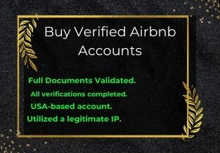

#### **Verified Account Benefits**

Having a verified Airbnb account comes with a range of benefits for both hosts and guests. Let’s take a look at some of the advantages:

1. **Enhanced Trust:** When you have a verified account, other users on Airbnb can see that you have gone through the verification process, which builds trust and reassurance.
2. **Secure Transactions:** Verified users can enjoy the peace of mind that comes with secure transactions. By knowing that the person you are dealing with has been verified, you can have more confidence in your bookings and payments.
3. **Priority Support:** Airbnb provides priority support to verified users, ensuring a more efficient and effective resolution of any issues that may arise during your Airbnb experience.
4. **Improved Search Results:** Hosts with verified accounts may receive higher visibility in search results, attracting more potential guests and ultimately leading to increased bookings
5. **Instant Bookings:** Some hosts may offer “Instant Book” options exclusively to verified guests. This feature allows you to make a booking without waiting for host approval, saving you time and providing added convenience
6. **Exclusive Offers:** From time to time, Airbnb may offer exclusive promotions and discounts specifically for verified users, allowing you to save money on your bookings
7. **Credibility as a Host:** If you are a host, having a verified account will enhance your credibility in the eyes of potential guests. It shows that you have taken the necessary steps to ensure a safe and secure stay for your guests.
8. **Global Recognition:** A verified Airbnb account carries weight not only within the platform but also in the wider travel community. It demonstrates your commitment to responsible hosting or being a responsible guest.

As you can see, there are numerous benefits to having a [**buy verified Airbnb accounts**](https://usasmmzillow.com/product/buy-verified-airbnb-accounts/). It not only provides a safer and more secure experience for all users but also offers additional advantages that can enhance your overall Airbnb journey

If you are considering creating or upgrading to a Buy Verified Airbnb Accounts, we offer the service of buying verified Airbnb accounts. With our assistance, you can skip the verification process and enjoy the benefits of having a verified account right away.

**Please note:** While we provide the service of selling verified Airbnb accounts, it is important to remember that Airbnb itself encourages individuals to go through the official Buy Verified Airbnb Accounts process to ensure the highest level of safety and trust on their platform.

Ready to take your Airbnb experience to the next level? Get in touch with us to buy a verified Airbnb account and enjoy the benefits that come with it!

#### **Unique Accommodations Worldwide**

**Airbnb** provides a diverse selection of unique accommodations, including cozy cottages, chic apartments, and even treehouses. With options to stay in local neighborhoods, travelers can immerse themselves in the local culture, giving them a more authentic experience. Airbnb accommodations are not just places to stay; they are destinations in themselves.

#### **Experiences Beyond The Stay**

**Airbnb** offers more than just a place to lay your head. Travelers can book experiences such as guided tours, cooking classes, and outdoor adventures to enhance their trip. These experiences allow travelers to connect with locals and gain a deeper understanding of the destination they are visiting. Whether it’s a sunset yoga session or a street food tour, Buy Verified Airbnb Accounts offers a wide range of activities to suit every traveler’s interests.

#### **The Importance Of Verified Accounts**

**Trust And Safety**

Verified Airbnb accounts play a crucial role in establishing trust and ensuring safety for both hosts and guests. When users undergo the verification process, it confirms their identity and builds confidence in the community. This helps to reduce the risk of fraudulent activities and provides a secure environment for all parties involved.

#### **Enhancing Your Travel Experience**

With verified Airbnb accounts, travelers can enjoy a more seamless and [**enjoyable experience**](https://usasmmzillow.com/product-category/banking-account/). By knowing that hosts are verified, guests can feel more at ease during their stay, allowing them to focus on enjoying their trip rather than worrying about the legitimacy of the accommodation.

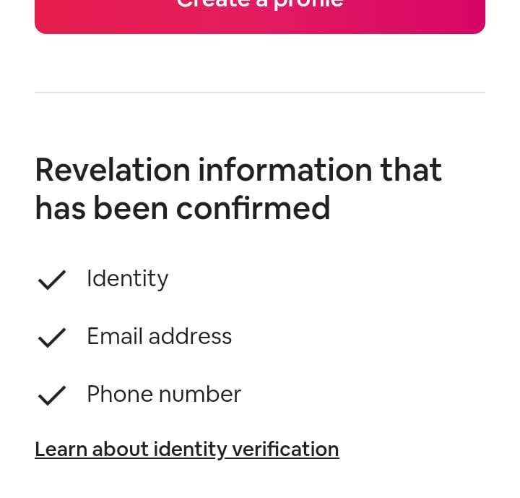

#### **How to Verify Your Airbnb Account:**

**Step-by-step Guide**

1. Log in to your Airbnb account.
2. Go to your account settings.
3. Click on the verification tab.
4. Follow the prompts to verify your phone number.
5. Upload a valid ID document.

#### **Common Verification Challenges**

1. Uploading blurry images may delay the verification process.
2. Ensure your ID document is not expired.
3. Double-check the information you provide for accuracy.
4. Contact Airbnb support if you encounter any issues.

#### **Buying Verified Airbnb Accounts: Pros And Cons**

Considering the option to purchase verified Airbnb accounts has its advantages and drawbacks. On one hand, it provides instant credibility and trust, but on the other hand, it may pose risks in terms of authenticity and security. Careful consideration is crucial before opting for this route. Buy Verified Airbnb Accounts

Buying Verified Airbnb Accounts: Pros and Cons Airbnb is a popular platform for travelers to find unique accommodations from local hosts. When signing up for an Airbnb account, users are required to go through a verification process to ensure their identity and reliability. However, some individuals may opt to buy a verified Airbnb account instead of going through the verification process themselves. In this article, we will explore the pros and cons of buying verified Airbnb accounts. Buy Verified Airbnb Accounts

#### **Immediate Benefits**

The most significant benefit of buying a verified Airbnb account is the convenience and time-saving aspect. Instead of going through the verification process, which can take several days, users can immediately start using the account and booking accommodations. This is particularly beneficial for individuals who need to book accommodations on short notice or frequently travel. Another benefit is that Buy Verified Airbnb Accounts have already established a positive reputation on the platform. Hosts may be more willing to accept bookings from verified accounts, as they are deemed more trustworthy. This can increase the likelihood of finding and booking high-quality accommodations.

#### **Potential Risks**

One of the most significant risks of buying verified Airbnb accounts is the potential for fraud. Some sellers may claim to sell verified accounts but provide fake credentials instead. This not only results in the loss of money but also puts the buyer’s personal information at risk. Additionally, Buy Verified Airbnb Accounts strictly prohibits the buying and selling of accounts, and users caught doing so may have their accounts suspended or terminated. This can result in the loss of all bookings and personal information associated with the account. Another potential risk is the lack of control over the verification process. When going through the verification process, users have control over the information they provide and can ensure its accuracy. However, when buying a verified account, users have no control over the information provided and may not be able to verify its accuracy. In conclusion, while Buy Verified Airbnb Accounts may offer immediate benefits and convenience, it also comes with potential risks. It is essential to weigh the pros and cons carefully before deciding whether to buy a verified account or go through the verification process independently.

#### **Navigating The Marketplace For Verified Accounts**

Navigating the marketplace to Buy Verified Airbnb Accounts can be tricky, but it’s important to ensure the legitimacy of the account before making a purchase. Look for reputable sellers with positive reviews and make sure to ask for proof of verification to avoid scams.

#### **Where To Look**

Start your search on reputable online marketplaces and forums.

Check for sellers with positive reviews and a history of selling verified accounts.

Look for accounts that come with verification badges and a money-back guarantee.

#### **Avoiding Scams**

Be cautious of deals that seem too good to be true.

Avoid purchasing accounts from suspicious or unverified sources.

Verify the authenticity of the account before making any payments.

Buy Verified Airbnb Accounts

#### **Legal And Ethical Considerations**

Buying verified Airbnb accounts has become a common practice for several reasons, including managing multiple properties, increasing bookings, and accessing discounts. However, before purchasing an Airbnb account, it is crucial to understand the legal and ethical considerations that come with it.

#### **Airbnb’s Policies**

Airbnb has strict policies against [**buying and selling accounts**](https://t.me/usasmmzillow/), and violators risk losing their accounts permanently. Airbnb’s policies state that each account must belong to a unique individual, and account sharing or transferring is not allowed.

Furthermore, Buy Verified Airbnb Accounts requires all hosts to undergo a verification process to ensure that they are genuine individuals and not scammers. Therefore, buying a verified account means that you are taking a considerable risk and may face legal consequences.

#### **The Fine Line Of Account Buying**

Buy Verified Airbnb Accounts is a risky endeavor that requires careful consideration of the legal and ethical implications. While some people may view it as a shortcut to success, it is essential to understand the fine line between what is legal and what is not.

Buying an account that has been verified by Buy Verified Airbnb Accounts. and it goes against the company’s policies. Doing so violates the terms of service agreement that hosts sign when they create an account on Airbnb. It can also lead to legal action against the buyer and the seller.

Moreover, it is unethical to buy a verified Airbnb account, as it is unfair to other hosts who have gone through the verification process. It also compromises the safety and trust of Airbnb’s community by allowing unverified individuals to access the platform.

Buy Verified Airbnb Accounts may seem like a quick fix to increase your bookings, but it comes with significant legal and ethical considerations. It goes against Airbnb’s policies and compromises the integrity of the platform. As a responsible host, it is crucial to follow the rules and regulations set by Airbnb and maintain the trust of the community.

#### **Maximizing Your Airbnb Experience With A Verified Account**

Are you looking for ways to enhance your Airbnb experience? Consider buying a verified Airbnb account. A verified account gives you access to exclusive features and benefits that can make your stay more enjoyable and stress-free. In this article, we’ll discuss the benefits of having a verified account and provide travel tips to help you make the most of your Airbnb experience.

#### **Unlocking Exclusive Features**

With a Buy Verified Airbnb Accounts, you can access exclusive features that are not available to non-verified users. For instance, Buy Verified Airbnb Accounts can book instantly, meaning they don’t have to wait for the host to approve the booking. This feature is especially useful if you are traveling on short notice and need a place to stay immediately.

Another exclusive feature that verified users enjoy is the ability to communicate with hosts even before booking. This feature allows you to ask questions and get clarifications on any issues you may have before making a reservation. It also allows you to get a sense of the host’s personality, which can be helpful when deciding whether to book a particular listing.

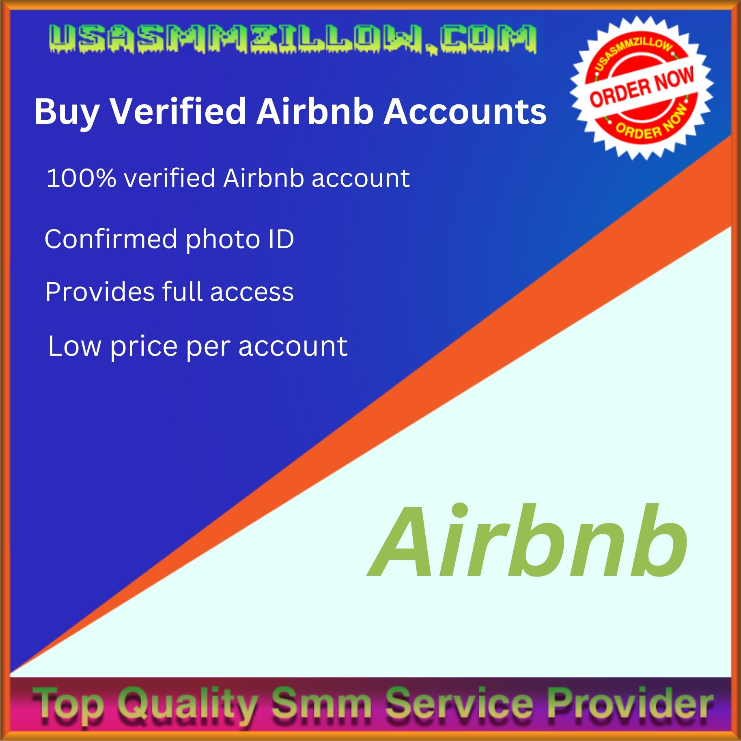

#### **Travel Tips For Verified Users**

As a Buy Verified Airbnb Accounts, you have an advantage over non-verified users. Here are some tips to help you make the most of your Airbnb experience:

* Take advantage of the instant booking feature. If you need a place to stay immediately, this feature can be a lifesaver.
* Communicate with the host before booking. This can help you get a sense of the host’s personality and whether they are a good fit for you.
* Read reviews from other guests. This can help you determine whether a listing is a good fit for you.
* Make sure to leave a review after your stay. This can help future guests make an informed decision about whether to book a particular listing.

By following these tips, you can maximize your Buy Verified Airbnb Accounts experience and ensure that you have a stress-free and enjoyable stay.

#### **Can I Buy Verified Airbnb Accounts?**

Yes, you can Buy Verified Airbnb Accounts from [**trusted providers**](https://usasmmzillow.com/). These accounts have undergone a verification process to ensure their authenticity and reliability. By purchasing a Buy Verified Airbnb Accounts, you can have peace of mind knowing that your Airbnb transactions will be secure and hassle-free.

#### **Why Should I Buy A Verified Airbnb Account?**

Buy Verified Airbnb Accounts offers several benefits. Firstly, it saves you time and effort in creating and verifying your own account. Secondly, it enhances your credibility as a host or guest, making it easier to attract bookings. Lastly, it provides an extra layer of security by ensuring that your transactions are with genuine and trusted users.

#### **Where Can I Find Trusted Providers Of Verified Airbnb Accounts?**

To find trusted providers of verified Airbnb accounts, you can conduct a search online and read reviews from other customers. Look for providers with a good reputation, positive feedback, and a secure payment system. It’s important to do your due diligence to avoid scams or fraudulent sellers. Buy Verified Airbnb Accounts

Purchasing verified Airbnb accounts offers a convenient and secure solution for both hosts and guests. With these accounts, users can avoid the hassle of verification processes and gain immediate access to the Airbnb platform. This not only saves time but also ensures a smoother experience, promoting trust and credibility in the sharing economy.

So, Buy Verified Airbnb Accounts if you’re seeking a hassle-free way to engage with Airbnb, buying verified accounts is worth considering.

# 